How to Create a
Defense Personal Property System (DPS)
Account
Access to DPS will be available via the internet or DoD communications networks
worldwide through the ETA (Electronic Transportation Acquisition) system. DPS interfaces with ETA to obtain user information, and ETA provides user authentication, access control, and security information to DPS depending on whether you have an existing ETA account or if you are a first-time ETA user.

- Visit the Move.Mil website at http://www.move.mil
- At the Home screen, click on DOD Customer
- On the right side of the screen, under Accessing DPS via ETA, click on the link: To Register for a DPS Account

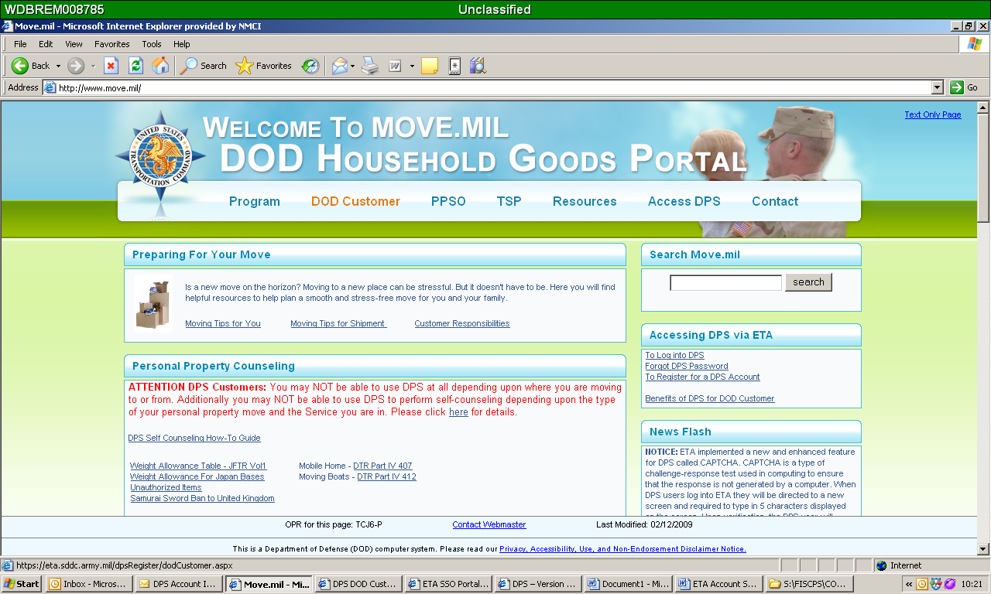

4. Fill in the information on the next screen to obtain your ETA User ID and Password.

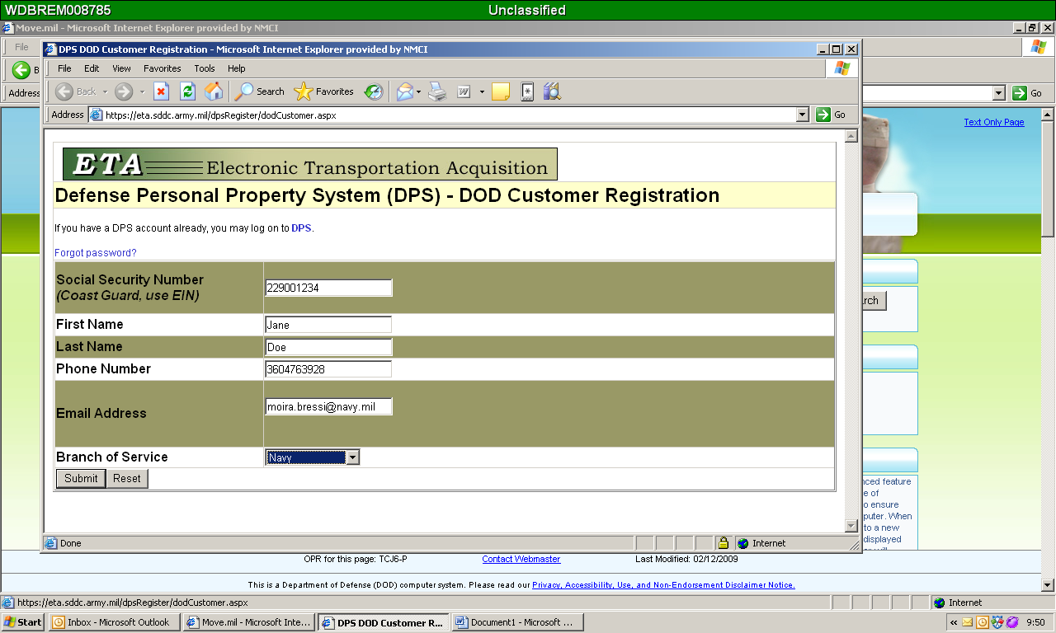

You will be emailed a Password to the email address that you provided. Your user ID is your full SSN or EIN (EIN is for Coast Guard ONLY).

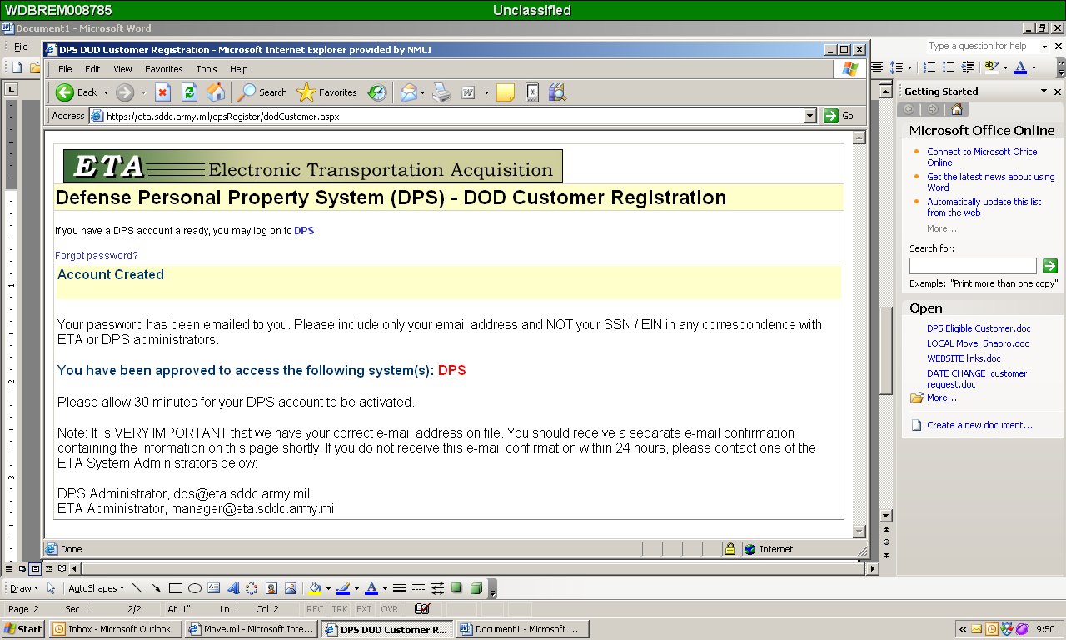

Once you have your password, go back into the Move.mil website and begin the process in DPS to start your move, by logging in and clicking on the “Counseling” Tab. (Retain this password as you will be required to log back into DPS to file a claim and complete your customer survey after your household goods have been delivered)

